April James

[jamesap@oregonstate.edu](mailto:jamesap@oregonstate.edu)

**Project #3: Duckball**

The third CS450 graphics assignment deals with texels, texture mapping, and texture distortion. The objectives included:

* Drawing an object with standard vertexes, along with s and t coordinates to map texture
* Importing a .bmp file to use as a texture image
* Providing the option to toggle texture mapping on and off to the object
* Providing the option to distort s and t coordinates in order to distort the texture image

Here are screenshots of my duckball in all its glory:

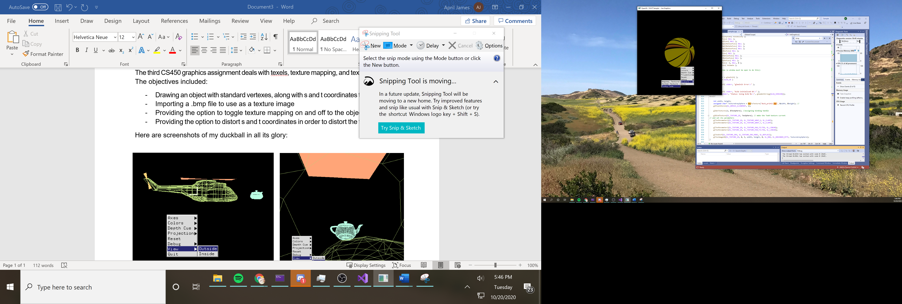 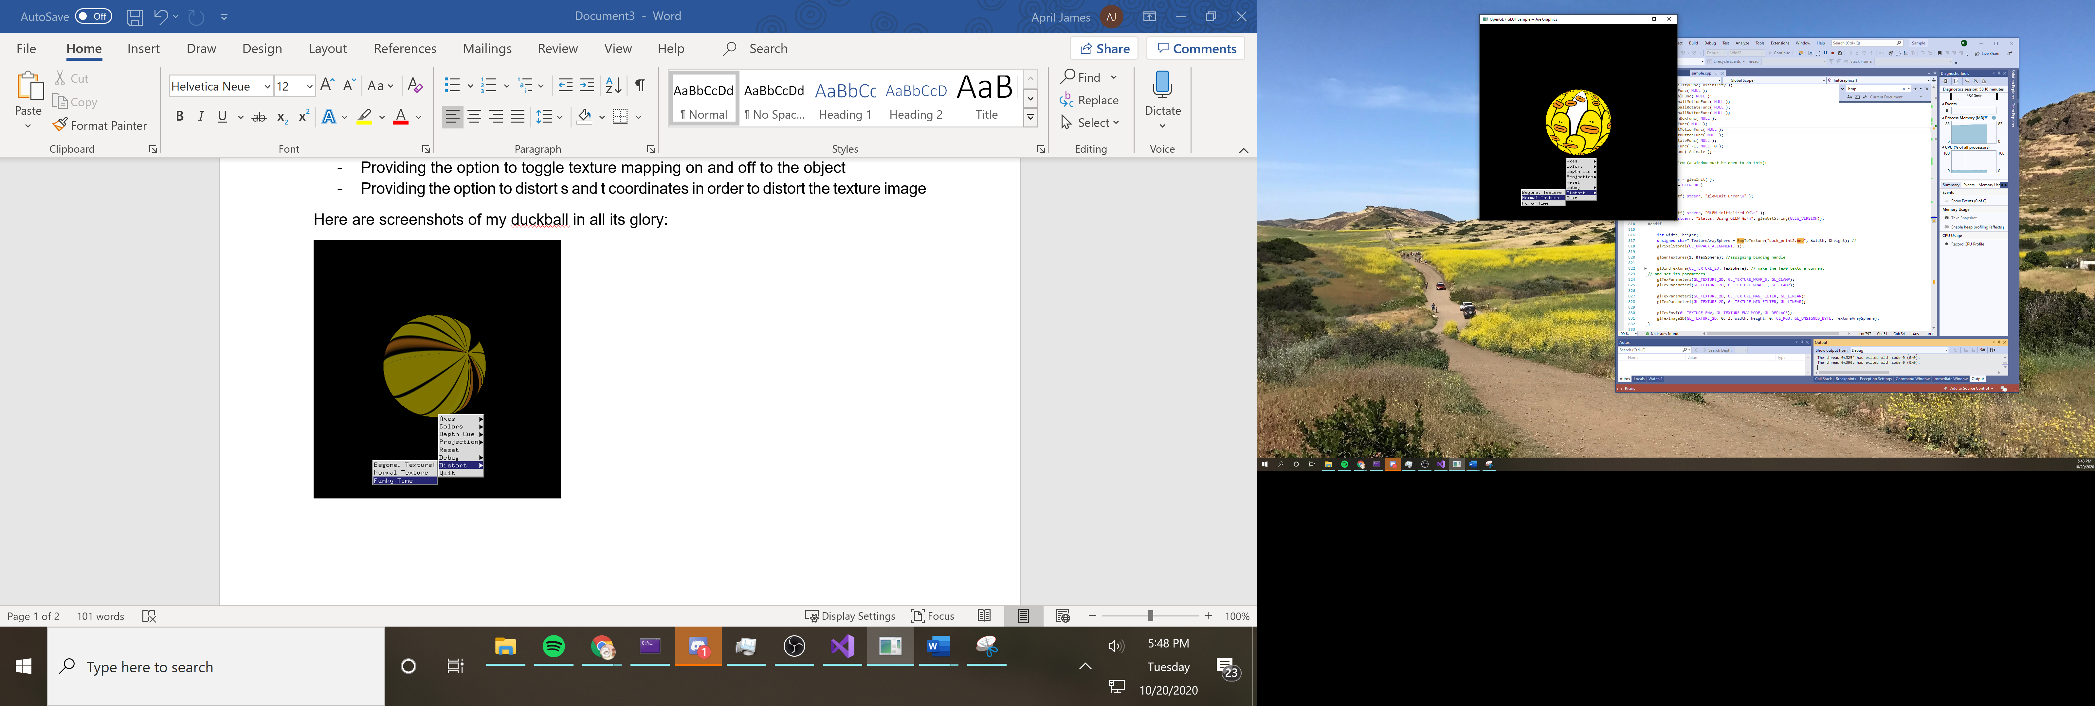 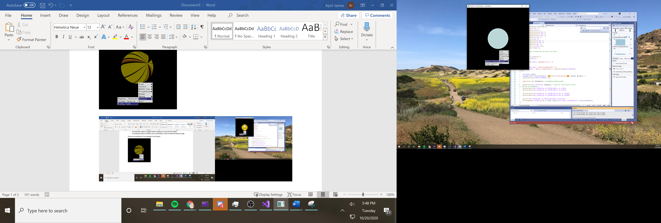

Here is a link to the project video: <https://youtu.be/859Pmhpr_94>

Thank you!